Nottingham Forest Supporters Club
South West & M5 Branch
Newsletter
‘Dum Spiramus Speramus’





Issue Ten – May & June 2002

Official Sponsors of John Thomson’s Away Kit
2002/2003 Season.

DISCLAIMER.

Whilst this Newsletter is the Newsletter of the South West & M5 Branch of the Nottingham Forest Supporters Club, it should be clearly understood that the contents do not necessarily reflect the views of Nottingham Forest Football Club, Nottingham Forest Supporters Club, Branch Members or
The Editor and should not therefore be interpreted as such.

SEC’S SPOT!

Welcome to Issue Ten of the Branch Newsletter.
IN ISSUE TEN
Page 1 Front Page
Page 2 Contents & Sec’s Spot
Page 3 SW & M5 Branch News
Page 4 SW & M5 Branch News
Page 5 SW & M5 Branch News
Page 6 SW & M5 Branch News
Page 7 Club News from NG2
Page 8 Club News from NG2
Page 9 Club News from NG2
Page 10 Club News from NG2

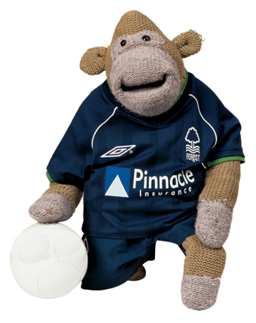

Is it my imagination but when the football season finishes time seems to be on a ‘go slow’ but whilst the season is underway it seems to go twice as fast?
Ah well at least we all have the World Cup to watch to rid us of our ‘withdrawal symptoms’ due to the lack of football!
It was my intention to put this newsletter out later this month but with the World Cup upon us I thought it appropriate to go to print with this issue now and to publish Issue 11 mid July when there should be more news from the club.
Although I stated in Issue Nine that I would be bringing you the match reports from the Sheffield Wednesday game onwards until the end of the season I have decided not to publish these and to basically put this issue out more as a ‘supplement’ rather than a full newsletter so as to keep you all up to date with the current information I hold and for updated plans for the branch.
The season finished with 90 branch members and 1 honorary member in John Thompson and hopefully next season we shall reach the ‘magical’ 100 mark! Don’t forget to ‘spread the word’ around.
Since November 2001 life has been a little hectic for me after my accident where I ruptured my left patella tendon and it is only now that there seems to be ‘light at the end of the tunnel’ with my recuperation.

To that end I would like to take this opportunity to thank everyone who has helped me during the last six months or have sent me his or her best wishes. A special mention must go to the following people: Mel, Rita, Joan & Pod of the Supporters Club, Mark Arthur, Jane Carnelly, Pippa Richards, Kay Wilson at the City Ground and all the staff of the Castle Suite who looked after me on match days. Also those branch members who travelled on the branch transport to games who helped me ‘hobble’ around and finally to Branch Member Ken Astley who spent many hours waiting around Derriford Hospital whilst I had my appointments (Don’t ask him about which entrance to use though) and not forgetting his lovely wife Jill who makes the best pies this side of Timbuktu! If I have forgotten anyone then apologies but you have all been tremendous!
Gizza Job Some One??

Oh before I close I have changed my mobile number yet again (sorry about that) and the new number effectively immediately is 07973 629717.

Enjoy your newsletter………………..

